Payroll



Base Pack

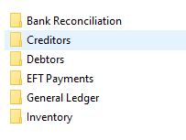

Information Intelligence

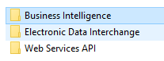

Addition Modules

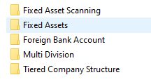

Inventory Modules

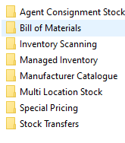

Job Costing

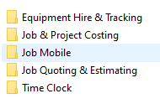

Purchasing

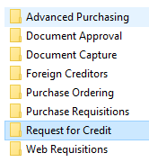

Sales

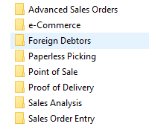

Future Pages and Logo’s not required at this time 2/8/2022

* Agent Seed Connect Web Module
* Extended Stock ½ Module
* Integrated EFT POS ½ Module